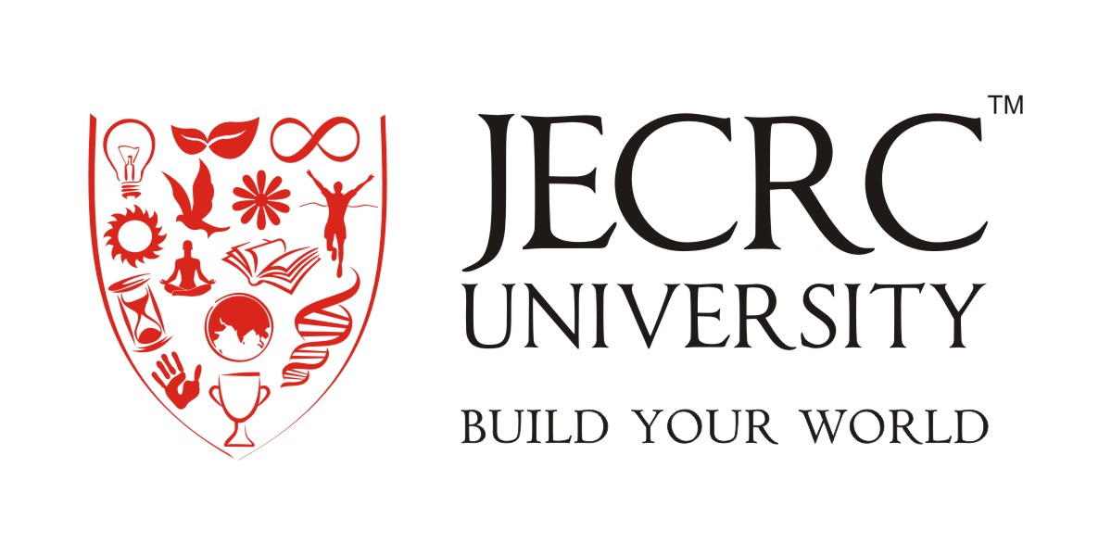

Operating Systems (BCA113A)

Assignment

|  |  |
| --- | --- |
| Submitted to:  Dr (Prof) Deepak Dembla  Head of Department | Submitted by:  Vayu Dugar (BCA)  Reg. No. – 18BCAN024 |

Department of Information Technology & Computer Applications

JECRC University, Jaipur

January – May 2019